Copy Blocks
RV22 Wi-Fi 6 Home Mesh Router
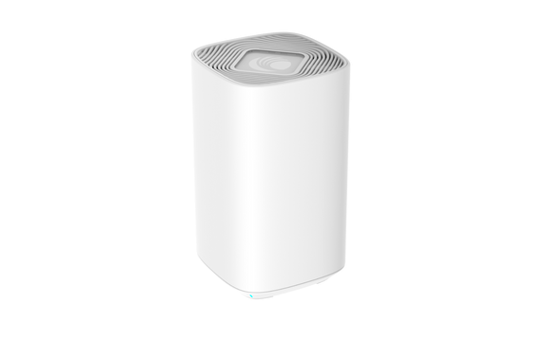
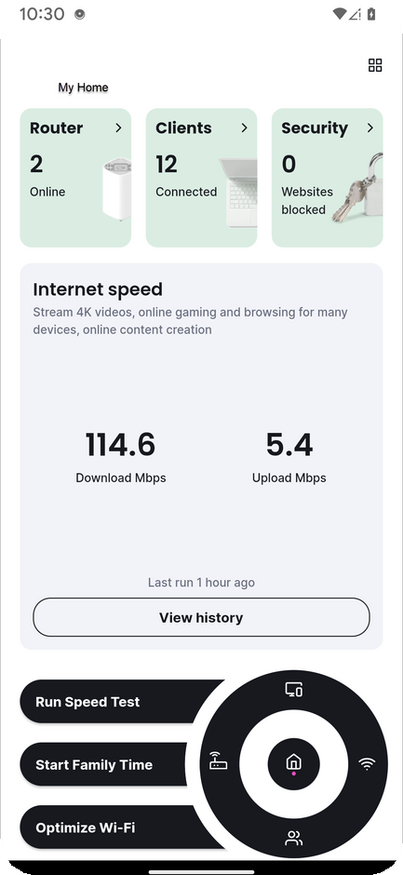
Create marketing materials with your company brand and contact information.

Amazing Home Wi-Fi
You’re in control with the RV22 Wi-Fi 6 Home Mesh Router
Easy-to-use app
Schedule family time, bedtime
Web content filters and guest access Optimize Wi-Fi for all your devices

Contact us to add the RV22 Home Router to your subscription.

You’re in Control of Your Wi-Fi
Add the RV22 Wi-Fi 6 Home Mesh Router to your subscription package Easy-to-use app
Schedule family time, bedtime
Web content filters and guest access Optimize Wi-Fi for all your devices

Contact us today to get control of your Wi-Fi.

Want Amazing Home Wi-Fi?
The RV22 Wi-Fi 6 Home Mesh Router Package offers amazing experiences to stream moves, connect home Wi-Fi devices, and more! In the easy-to-use app, you can:
Schedule family time, bedtime
Filter web content and offer guest access Optimize Wi-Fi for all your devices
Run speed tests
And more!

Contact us to add the RV22 Wi-Fi 6 Home Mesh Router to your subscription.

