AP-SM-CHILD SETUP:
AP-SM-Child setup is supported only for PMP/ePMP which works as AP/SM where we can attach any E-series/R-series device as a child.
This setup can be created on cnMaestro cloud as well as On-Premises.
For cnMaestro Cloud:
cnMaestro cloud supports zero touch configuration that allows PMP/ePMP SMs to automatically appear in the Onboarding Queue, provided if parent AP is already onboarded.
To enable zero touch configuration, navigate to Administration>Settings>Zero Touch Onboarding of SM Devices:
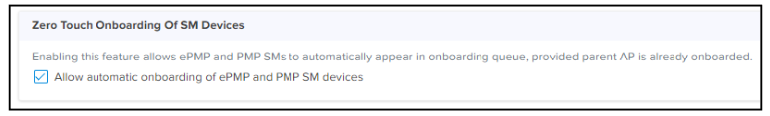
Onboarding PMP/ePMP (AP):
To onboard PMP device to cnMaestro, in the device UI
1. Navigate to Configuration > cnMaestro.
2. Under Configuration, provide the following details:
a. Select Enable under Remote Management.
b. Enter the URL to connect to cnMaestro in the cnMaestro URL textbox.
3. Under Credentials, enter the Cambium ID and the Onboarding Key in the respective textboxes. The Account ID field displays the account id of the user.

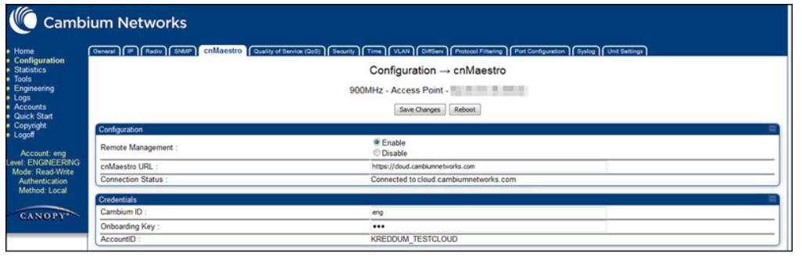

Onboarding Cn-Pilot (Child device):
To view the status of the cnPilot R-Series device connection to cnMaestro:
1. Navigate to Administration > cnMaestro.
2. Under cnMaestro configuration section.
3. Enter the URL in the cnMaestro URL.
4. Click Save
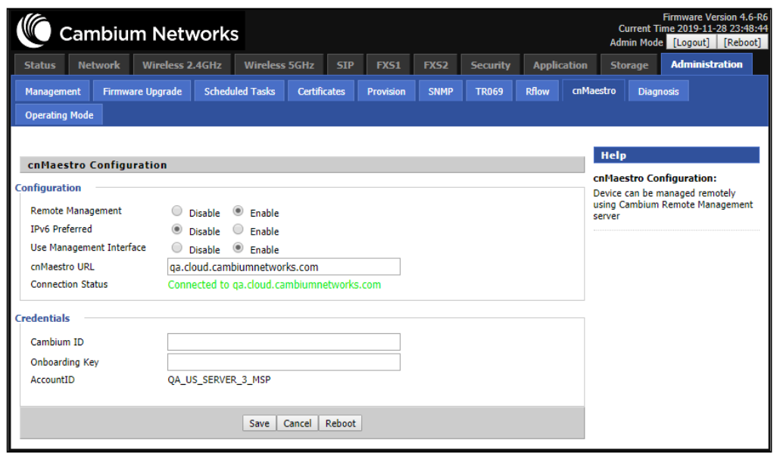

We can claim device using serial no in cnMaestro
a. Navigate to Onboard page > click Claim Device
b. Enter the Serial Number of the device.
c. Click Claim Devices.
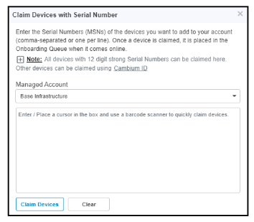

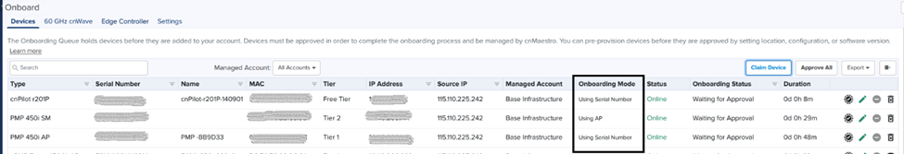
Here PMP AP is onboarded using serial no. PMP sm is onboarded using zero touch configuration. Child device CnPilot is onboarded using serial number. These devices are waiting for approval. Once these devices are approved, they will be managed under Base Infrastructure by default.

FOR Cnmaestro On-Premises:
Zero touch onboarding for PMP/EPMP: Enable Zero touch onboarding PMP/ePMP SMs to automatically appear in the onboarding queue if the parent AP is already onboarded (There is no special option available in NOC to enable zero touch onboarding as of cloud). Child devices can be claimed using serial no or MAC address.

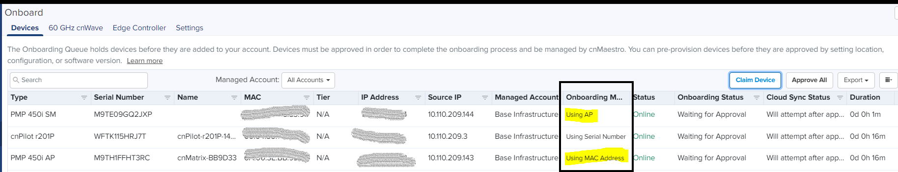
NOTE: AP-SM-CHILD setup works only if devices are in same subnet.

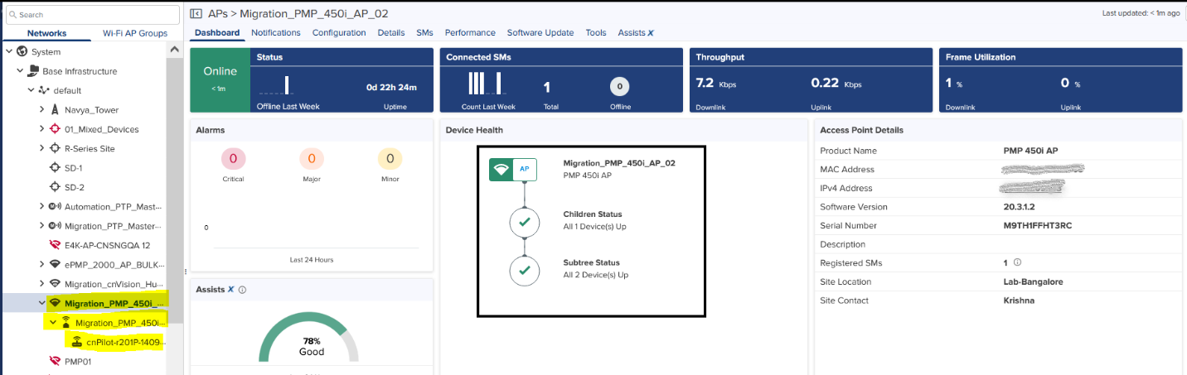
In Fig. AP-SM-Child are managed under Base Infrastructure by default.
PMP/ePMP devices supports tower configuration and e series/r series support site configuration. We can change tower configuration only for AP and SM and child will follow the same configuration as AP.
Tower configuration can be changed by navigating to AP configuration page:
To Apply tower configuration for child device:
1.navigate to AP>configuration>tower
2.Put device under any available tower
3.APply configuration.
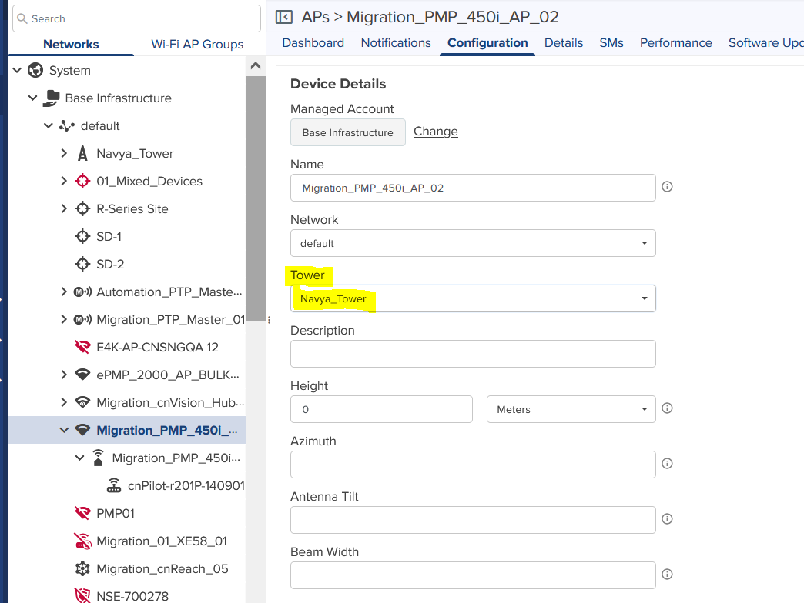
Once Tower configuration is applied, AP-SM-child setup comes under same tower.
Here site details are not configured for child devices.
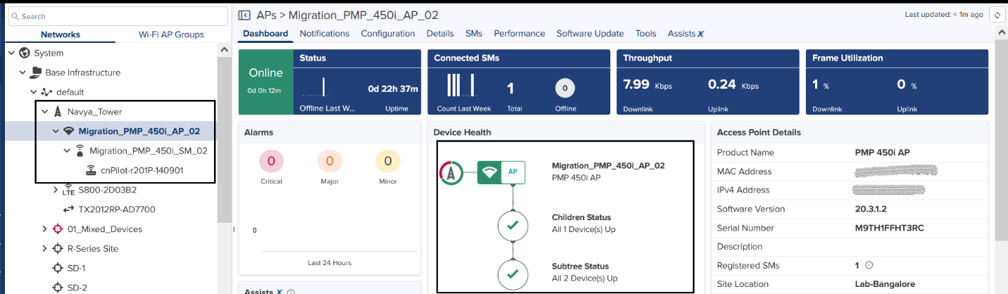

To apply site configuration for child device:
1.navigate to child device>configuration>site
2.Put device under any available site.
3.APply configuration.
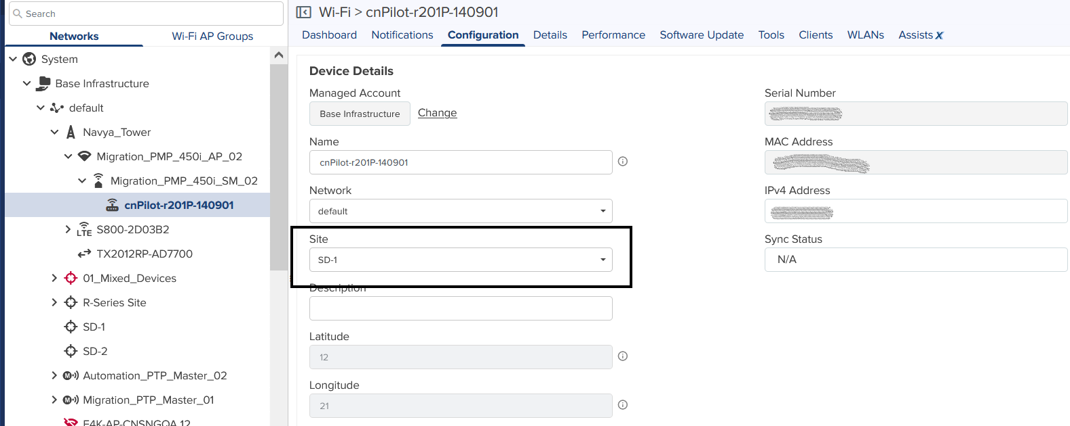

Once the site details are applied, child devices go under particular site. If we undo the changes the child device goes back under SM in tree level.
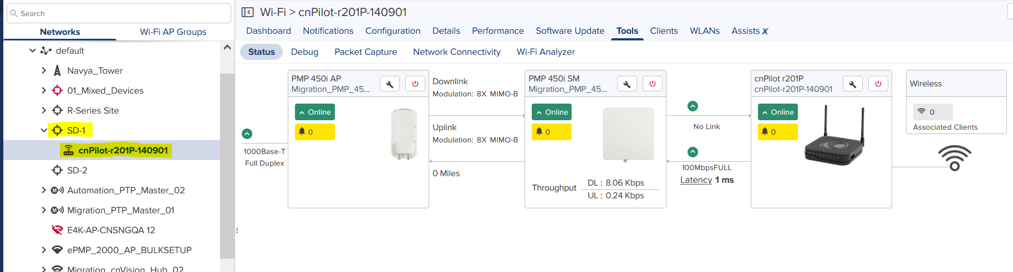
We can even change the AP-SM-Child setup under Managed Accounts. Both AP and child will have the option to change its managed accounts in their configuration.SM will follow its AP for managed accounts.
To change Managed Accounts in AP/Child device:
1.Navigate to device level>configuration
2.Chose a managed account
3.APply configuration.
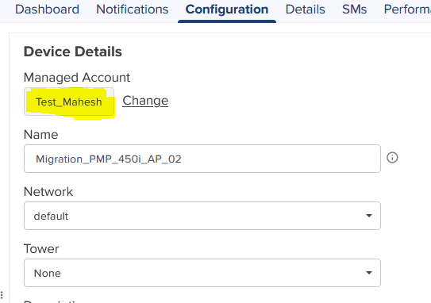

A] If we change managed accounts only in AP, AP-SM-CHILD setup will move under the same managed account.
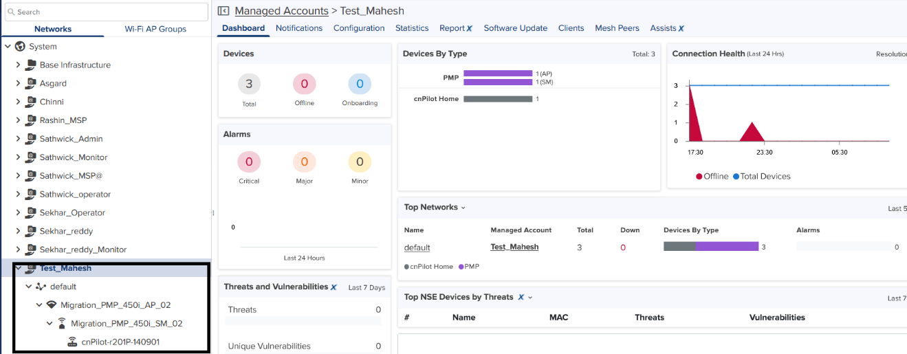
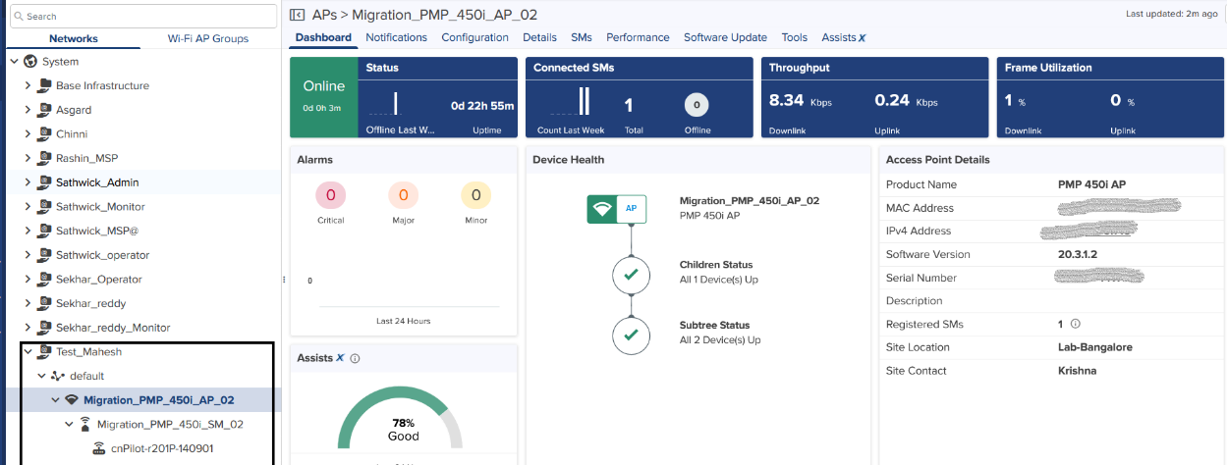

B] AP is under one managed account and if we move the child under another managed account, the child will get managed under the managed account provided. The AP-SM-CHILD link will be disconnected.
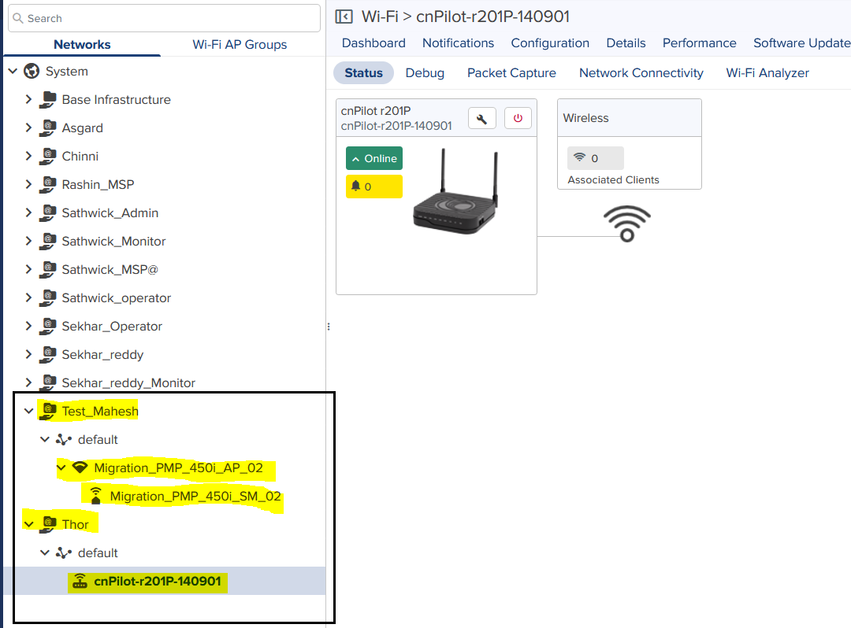
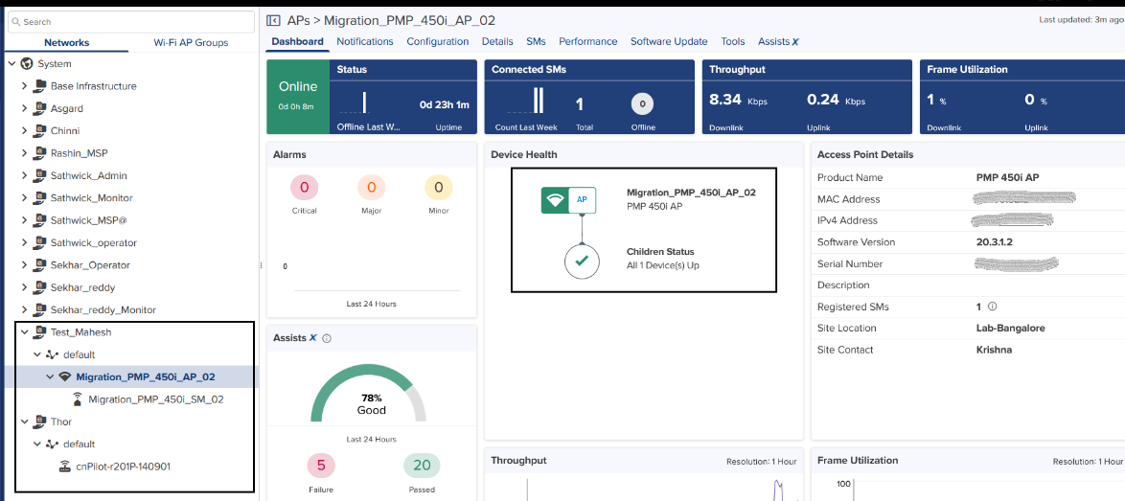
The changes will be reversed if we UNDO the changes in managed accounts.

