DATA AND MANAGEMENT VLAN CONFIGURATION
This document will explain the requirements and configuration required to implement a single cable solution for the PTP 820E and PTP 850S radios. A single cable solution allows connectivity with one cable which carries management, traffic, and power.
Cause:
It is often preferred to have a single cable run up the tower to the radio unit to reduce cost and complexity.
Solution:
- The single cable solution was introduced in the 11.3 software release.
- Limitations:
  - Management service point should be modified from its default value of dot1q Untagged (management traffic needs to be tagged to specific C VLAN/S VLAN)
  - Cannot belong to LAG groups
  - Does not support MSTP and G.8032
  - Automatic State Propagation can only be used in Safe mode
Note:
Once the management port is enabled to carry traffic, a Service Bundle Shaper (ID 256) is attached to this service. This Shaper cannot be edited and must be either detached or disabled on the port for the port to support 1Gb/s traffic.
Single Cable Over MNG Configuration
- Modify the actual port speed to 1000 Mbps
- Disable default management port Shaper (ID 257)
- Enable LOC alarm management port
- Change the VLAN encapsulation of the management service point from Untagged to a specific VLAN (C tag/S tag)
PTP 820E
PTP 850S
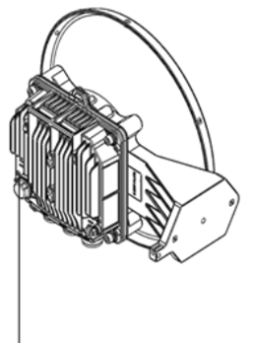
Management
- Traffic
- Power
- Modify actual port speed to 1000 Mb/s
• Ethernet > Interfaces > Physical Interfaces > Modify the port speed to 1000 Mbps
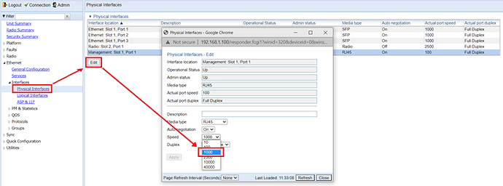
Picture2778×289 70 KB

- Disable management port shaper
• Ethernet > Interfaces > Logical Interfaces > Disable management shaper
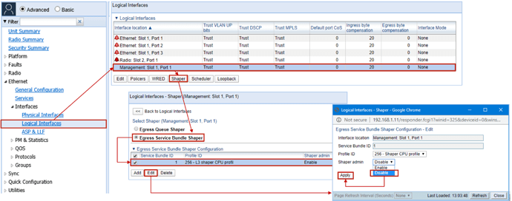
Picture31465×579 304 KB

- Enable LOC alarm support on MNG port
• By default, the LOC alarm on management port is disable
• Platform → Interfaces → Traffic over Management → Enable LOC alarm
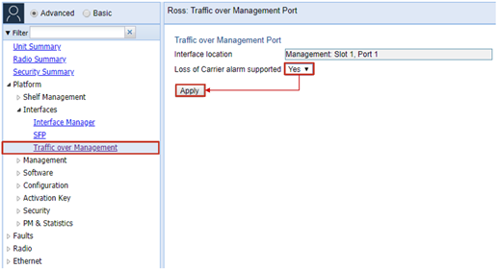
- a. Management SP configuration for MNG service
Example of MNG dot1q with C-VLAN for management:
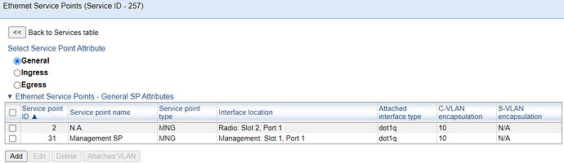
Picture 11193×347 19.2 KB

Note: Management service points should be tagged. Leaving the management service
point as Untagged will result in untagged data traffic being classified into the
management service.
This should be avoided!!!
b.Management SP configuration for traffic service
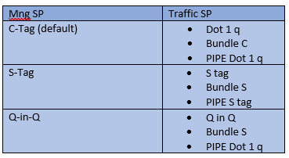
  - If the management service point is configured as dot1q Untagged, you will be unable to configure the PIPE service point.
  - To use management port in P2P service as untagged PIPE service point the user needs to add tag to the service point inside the management service.
  - Recommendation: configure a PIPE service point for data traffic on the management port. This service point should be untagged (e.g., dot1q untagged or Bundle untagged or Bundle C with “Untagged” as the C VLAN encapsulation).
Example for PIPE dot1q traffic service:
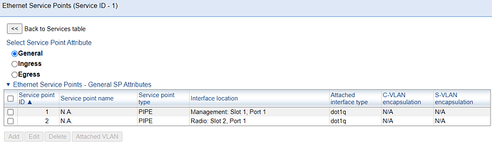
Picture 21191×352 18.9 KB

Note: To avoid the problem of changing the tagging of management traffic in the middle of the service point reconfiguration process, it is recommended to perform this process, if possible, by accessing the unit via the EXT port, with a special cable.

