Connect to the ePMP2000 radio GUI and go to Configuration>Radio>General and set “Radio Mode” to “Spectrum Analyzer”:

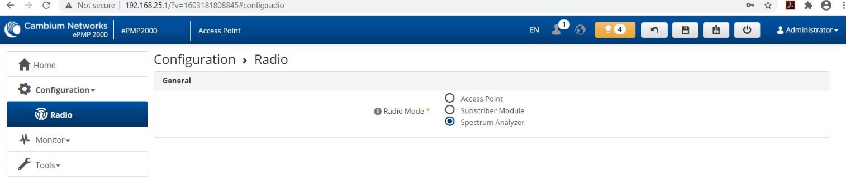

Save changes and reboot device. Same instruction is in warning message in GUI>Tools>Spectrum Analyzer
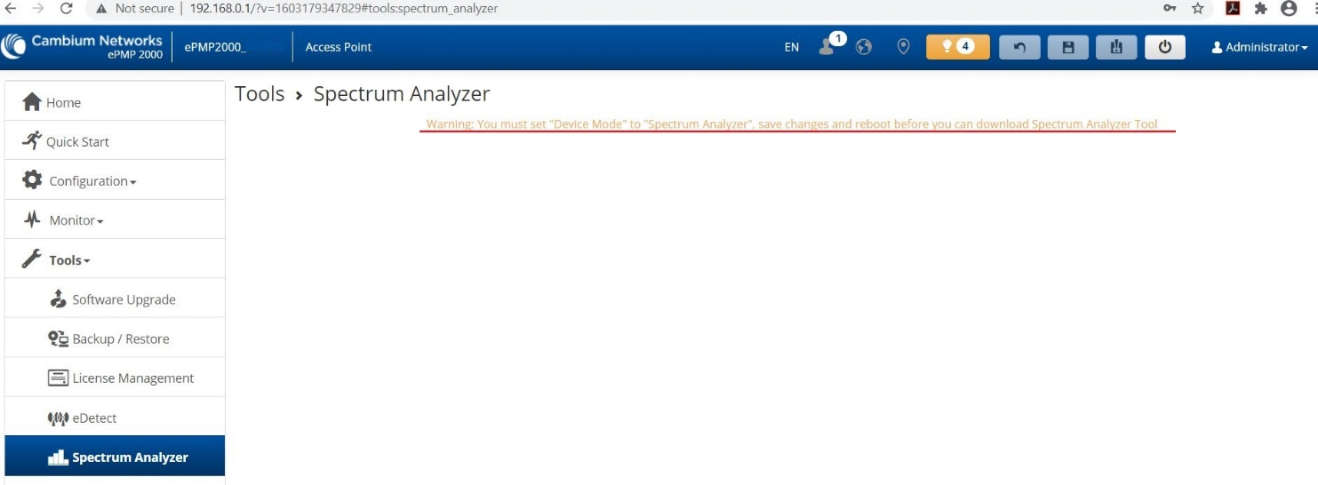
After device reboot connect to GUI and go to Tools>Spectrum Analyzer and click Download Spectrum Analyzer Tool
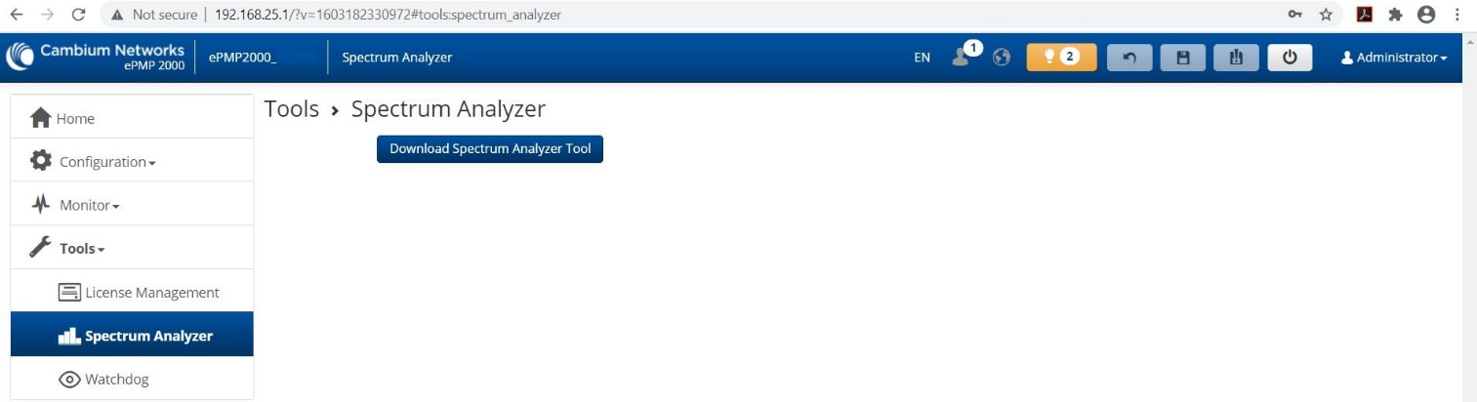
This will lead to support web page: https://support.cambiumnetworks.com/files/epmp_tools_and_docs/
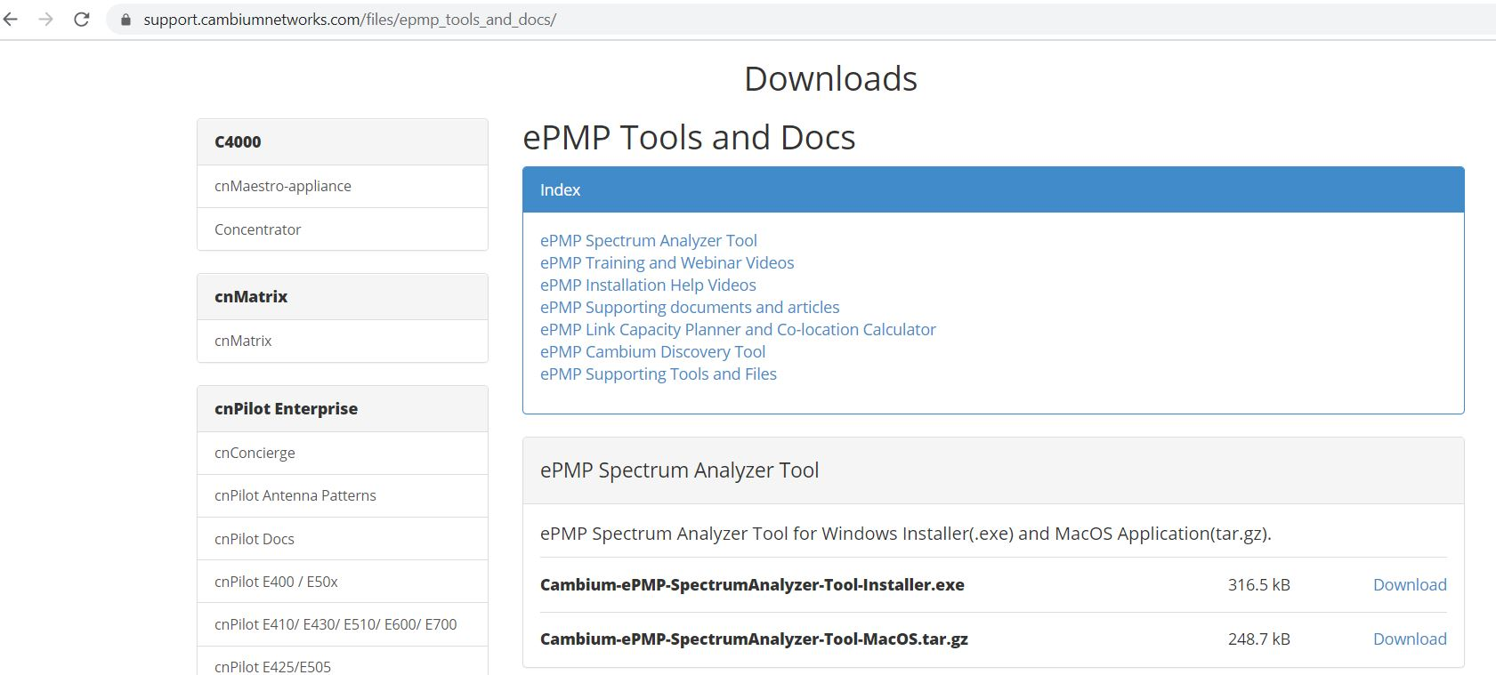

Select and download file for your system.
Install Spectrum Analyzer tool. Java Run Time Environment installation can be required.
Start Cambium SA tool and update Device IP Address if required according to real value and save.
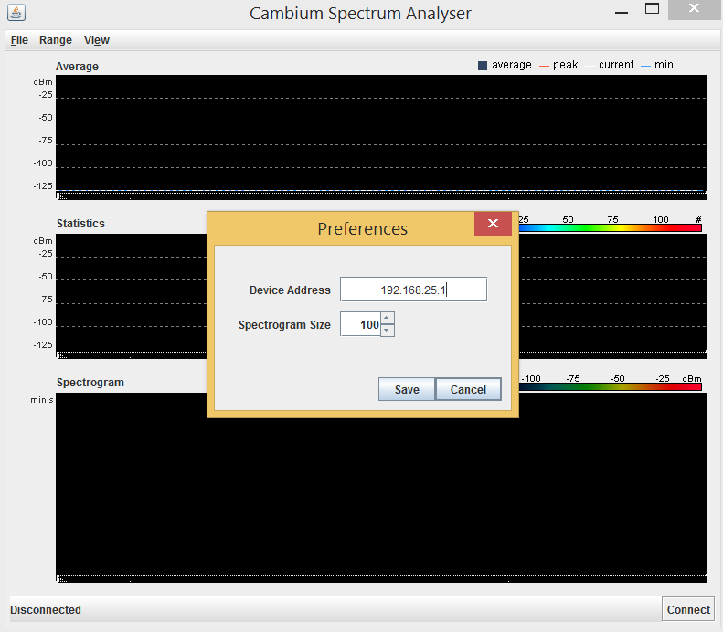
IP address can be checked in GUI>Monitor>Network>Ethernet Interface>IP Address
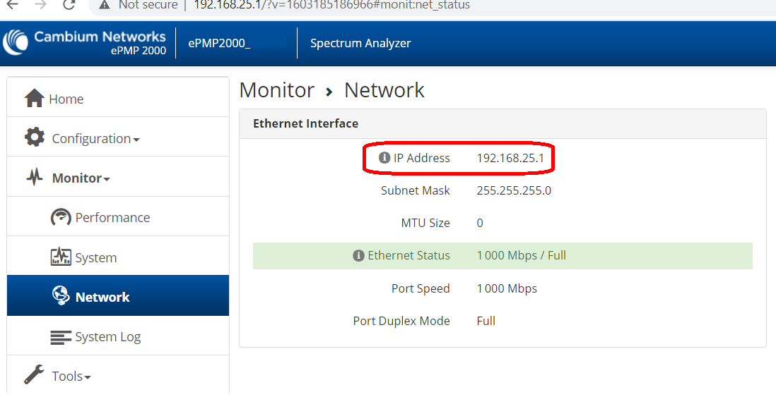
169.254.1.1 – Fallback IP can be used

Click “Connect” in Cambium SA tool.
Frequency Range for scanning can be selected on this stage:
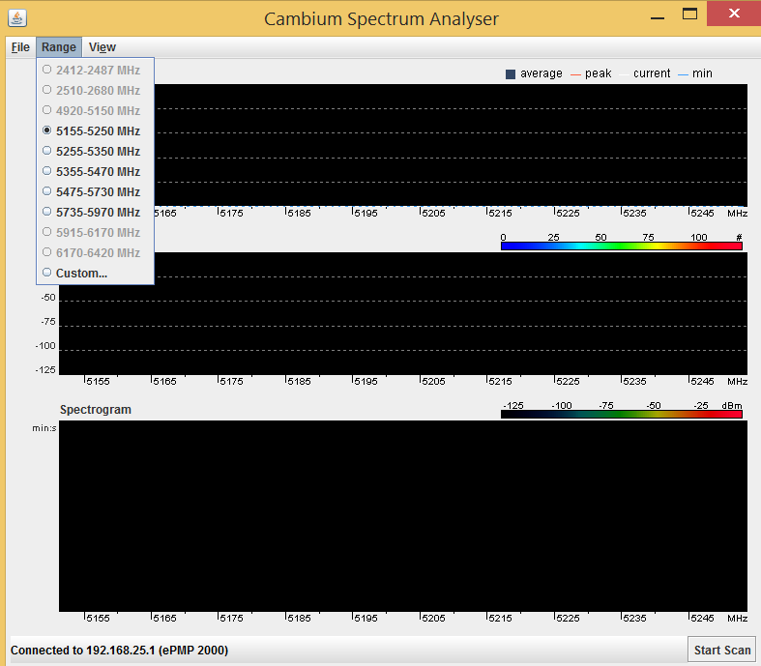
After selecting frequency range click “Start Scan”.
Results will be displayed on the graph(s).
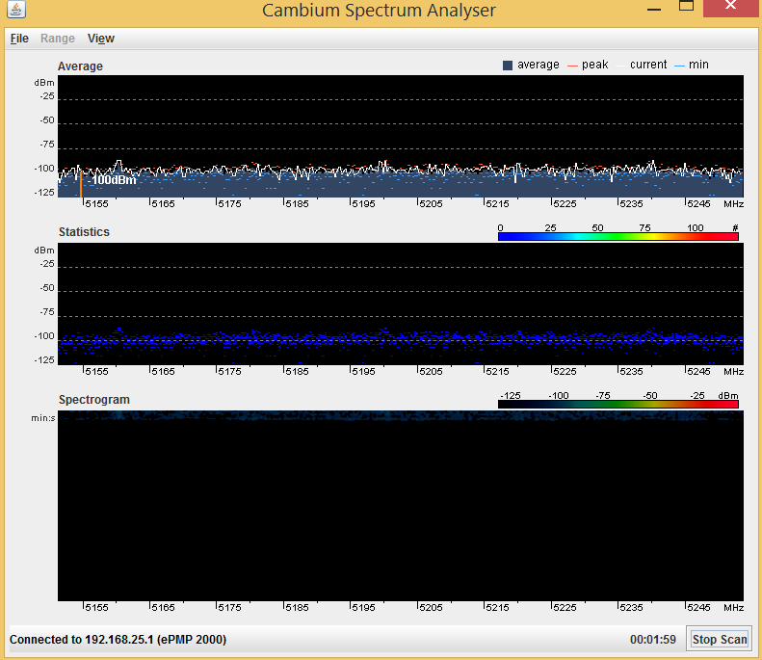
Note that Cambium SA tool communicates via port: 8001, so it must not be blocked by Firewall.
ePMP2000 radio must be in Spectrum Analuzer mode otherwise Cambium SA tool will not be able to connect to it.

